Health Lesson # 7

Teeth and Dental Health Review

Hey everyone,

Hope all is well! We are very proud of all the work you kiddos have been doing with this unit on teeth. Remember how important it is to take care of them because as we have been learning, once you get your permanent set, you do not get any more! Please review everything we have learned and watch these videos from brainpopjr. After watching the videos, try takng the quizzes associated. If for some reason the links do not work, you can log in to find them using the username- PhysEd2020 and password- StayFit2020. Keep up the great work! We miss you all very much!

* Mr. Feiss & Mrs. Miller

<https://jr.brainpop.com/health/teeth/caringforteeth/>

1. About how long should we brush our teeth?

<https://jr.brainpop.com/health/teeth/goingtothedentist/>

1. 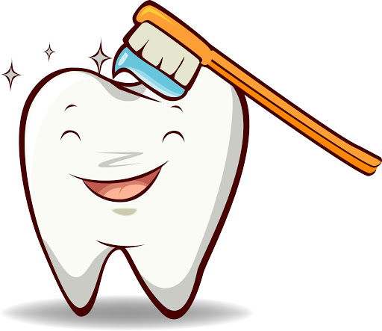What can you do at home to keep your teeth strong and healthy?

<https://jr.brainpop.com/health/teeth/losingatooth/>

1. 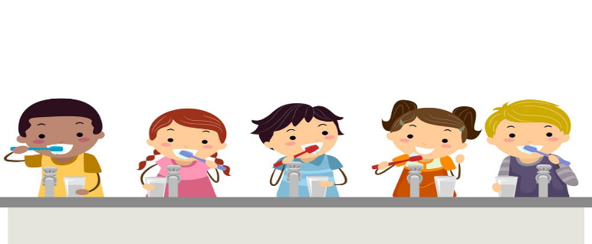Who is the doctor who helps with your teeth?